
Mathematics Essential

Name: ______________________

Task 2.5 – Unit 2

Assessment type: Response - Skills

Conditions:

Time for the task: 30 minutes

In class, calculator permitted
Marks: marks ______/ 31

Task weighting:

2% of the school mark for this unit

_____________________________________________________________________________
Question 1:

- ½ of 60
- 0.5 x 120
- 1.25 hrs = ________ mins
- Write ¼ as a decimal
- 0.25 hours = ______ mins
- 45 mins = ______ hours
- A fortnight = __________ days
- September has _________days
- 5% of 250
- Simplify the ratio 4:12

Question 2:
Convert the following to 24hour time
- 1.30 am
- 10.14 pm
- 3.07 pm
- 2.22 pm
- 12.10 am
Question 3:
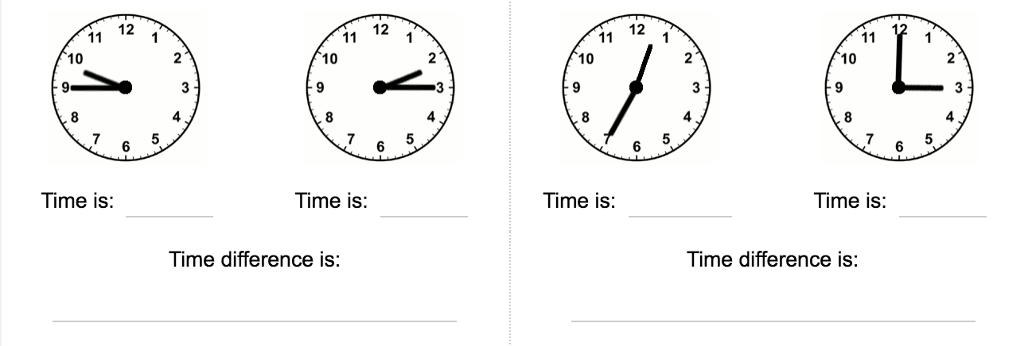

Question 4:
Write the differences between the two times

- 1:35 p.m. and 5:40 p.m.

- 8:45 a.m. and 11:20 a.m.

Question 5:
If Noah takes a group of friends to the movies for his birthday, it would cost $62.50 for five tickets, how much would it cost if there were 12 people (including Noah) in the group?

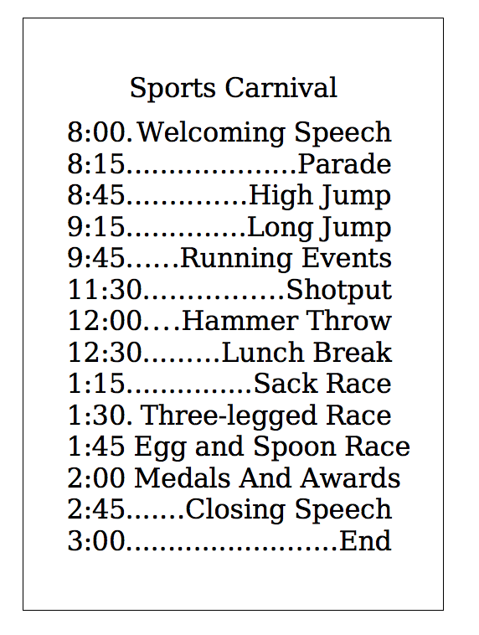
Question 6: From the timetable below calculate the following
- Is the Welcoming Speech the same length as the closing speech?

- How long is the Parade?

- How long is the Lunch Break?

- Which events are half an hour long?

- How much time will the running events take

- How many hours long is the carnival?

- It takes Mrs Jones two and a half hours to get to the school from work. What time should she leave work, if she wants to arrive in time to watch her son and daughter receive their medals?

